*Balsamic Miso Root Salad*

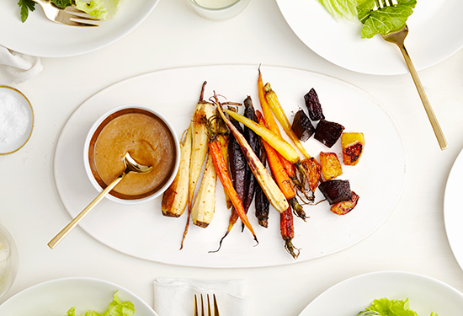

We originally made a miso tahini dressing for this, but did some playing in the test kitchen and swapped the tahini for a sweeter balsamic – it ended up making the salad.

*ingredients*

makes 4

*for the veggies*

* about 2 lbs mixed root vegetables (we use baby carrots, the smallest parsnips you can find and a mix of yellow and red beets)
* olive oil
* salt + pepper

*for the balsamic miso vinaigrette*

* 2 tablespoons sesame oil (untoasted)
* 2 tablespoons balsamic vinegar
* 2 tablespoons white balsamic vinegar
* 2 tablespoons yellow miso

*preparation*

|  |  |
| --- | --- |
| 1. | Gently peel the carrots and parsnips. Leave them whole if they are all the same size – if not, chop the larger veggies to equal the size of the smaller ones. Peel and chop the beets into rough cubes, about 1-inch all around. |

|  |  |
| --- | --- |
| 2. | Place all the veggies onto a baking sheet. Season with salt and pepper and drizzle lightly with olive oil. Place in a 400°F degree oven and bake for about 20-25 minutes, shaking them periodically for even cooking. Remove from oven when soft, slightly brown and caramelized. |

|  |  |
| --- | --- |
| 3. | Meanwhile, make the dressing. Place all the ingredients aside from the oil in a mixing bowl. Drizzle in the oil while whisking to combine. Season to taste. |

|  |  |
| --- | --- |
| 4. | Plate veggies with dark, leafy winter greens of choice and drizzle dressing generously over top. |